Write a pig script to find the count of each Hashtag in the dataset. You can download the twitter data from the below link

**Pigscript:**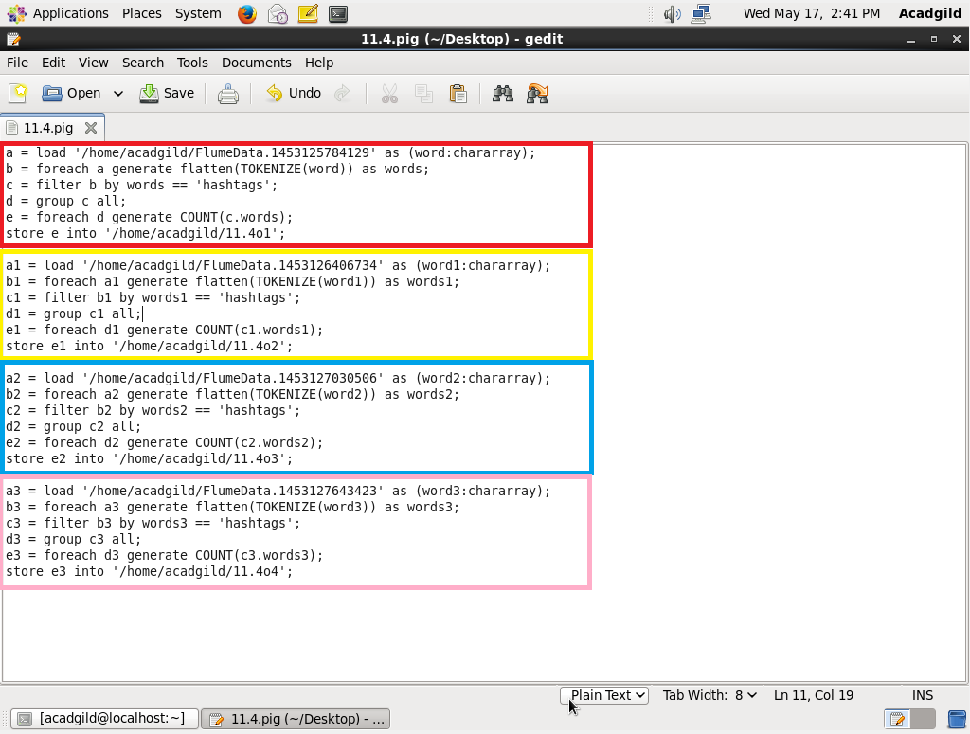

**Running pigscript:**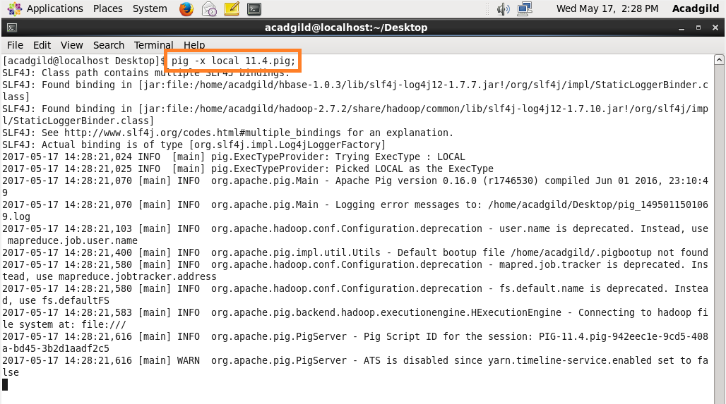

**Output:**

